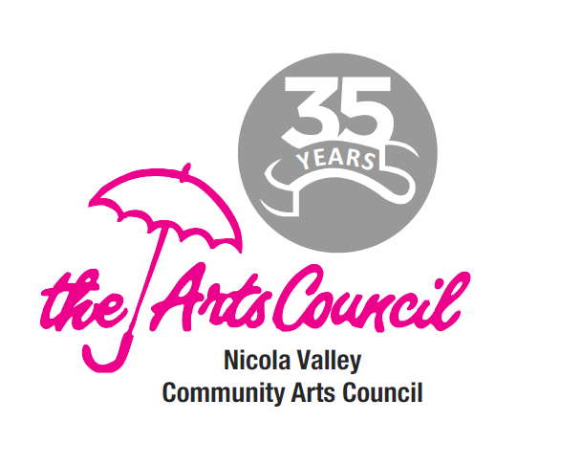
Nicola Valley Community Arts Council

Program Application Form:
Promotion Information Page

Name of Project/Event:

Organization: Main Contact:

NVCAC Promotion Contact:

Start / Finish Dates: and times:

Location:

Registration Fee: $ Deadline to register:
or
Ticket costs: Adult $ Children $ Student $ Senior $ Family $

Registration/Ticket purchase at these locations:
o Live button online at NVCAC website and social media posts
o Merritt outlets:
o Available at the door (note ticket price change, if any)

Info statement for press release, advertising, posters, etc. (who, what, when, where, why)

Note - the NVCAC funders’ logos must appear on all publications.
