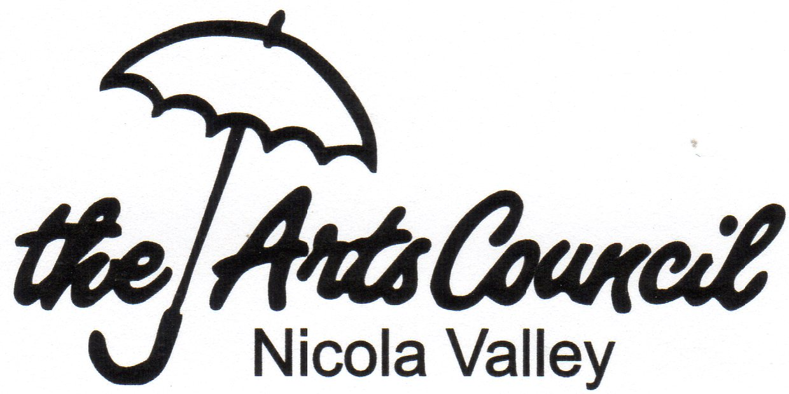
Nicola Valley Community Arts Council

1840 Nicola Ave,
PO Box 2762, Merritt, BC V1K 1B8
Tel: 250.378.6515
nicolavalleyartscouncil@gmail.com
www.nicolavalleyartscouncil.com

Support Process for New Programs and Activities

We encourage members to initiate, plan, and run programs that serve participants of all ages, and interests. We welcome opportunities to collaborate with local groups in a variety of arts and culture activities. We also welcome proposals from other organizations who have activities involving the use of art, music and cultural events. The program support process has several steps:

- Program Application Form outlines your proposed project or event and helps us consider how it might best fit into Arts Council programs. We may be able to give organizational support, a volunteer force, promotion and networking, or direct financial support from our programming budget. With sufficient information and time, the Council can seek grants that would be appropriate to your project.

- Budget page helps us to identify additional ways to assist you, possibly as part of programs we already have in place. Sometimes it helps us identify funding that may be available through other agencies and make successful applications for additional grants.

- Promotion Information and Promotion Planning forms enable the project to be advertised in available local and online media.

- The Final Report on your project is very important to the Council in planning future activities. These are used in future grant applications to show that programs are happening and that the public is being served.

- The Financial Report may be required before we reimburse expenses.

If you have any questions or need help to complete this application, we are happy to help. Please apply as early as possible to give us time to find additional funding sources, such as grants or in-kind donations. You may add details later if there are changes or additional information available. When your application is approved, other forms will be provided to assist in promotion and reporting the program results.

We look forward to receiving your proposal and working with you for success.

